Salem Lutheran Church
602 W. Townline St. * Creston, IA 50801
Fifth Sunday after Epiphany
February 7th, 2021

Church Website: www.salemluth.net * Secretary E-mail: office@salemluth.net
Interim Pastor: Cal Oraw * 406-480-1322 * cj.oraw@yahoo.com
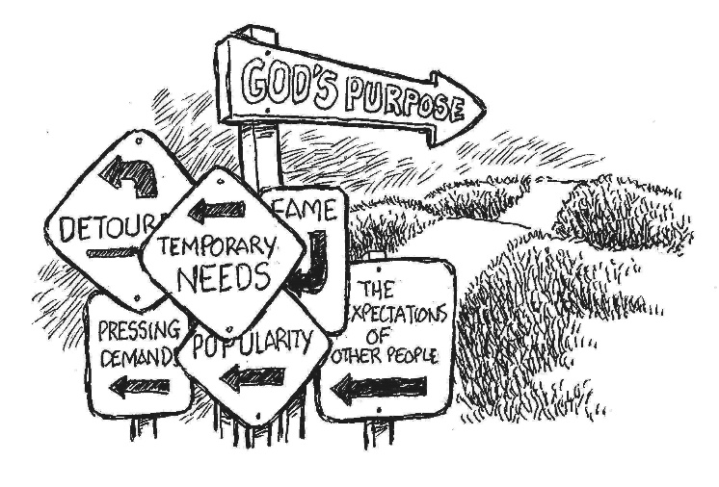
Welcome

OPENING Hymn Great God, Your Love Has Called Us

Confession and Forgiveness
P: We gather here in the name of the Father, and of the ☩ Son, and of the Holy Spirit. Amen.
P: Let us confess our sin in the presence of God and of one another.
P: God of goodness and lovingkindness,
C: we confess that we have sinned against you and our neighbors. We have turned away from your invitation to new life. We have turned away from the lowly and downtrodden. In your abundant mercy, forgive us our sins, those we know and those known only to you, for the sake of the one who came to live among us, Jesus Christ, our Savior. Amen.
P: People of God, hear the good news: by God’s endless grace our sins are forgiven, and we are free—free from all that holds us back and free to live in the peaceable kingdom of God. May we be strengthened in God’s love, ☩ comforted by Christ’s peace, and accompanied with the power of the Holy Spirit.
Amen.

Opening Prayer
Everlasting God, you give strength to the weak and power to the faint. Make us agents of your healing and wholeness, that your good news may be made known to the ends of your creation, through Jesus Christ, our Savior and Lord. Amen.

First Reading: Isaiah 40:21-31

Second Reading: 1 Corinthians 9:16-23

Gospel: Mark 1:29-39
Sermon

Hymn Thy Word Is A Lamp

With the whole church, let us confess our faith:
I believe in God, the Father almighty, creator of heaven and earth.
I believe in Jesus Christ, God's only Son, our Lord, who was conceived by the Holy Spirit, born of the Virgin Mary, suffered under Pontius Pilate, was crucified, died, and was buried; he descended to the dead. On the third day he rose again; he ascended into heaven, he is seated at the right hand of the Father, and he will come to judge the living and the dead. I believe in the Holy Spirit, the holy Christian church, the communion of saints, the forgiveness of sins, the resurrection of the body, and the life everlasting. Amen.

Prayers of Intercession
response to prayers: Hear our prayer.

Lord’s Prayer
Our Father, who art in heaven, hallowed be thy name, thy kingdom come; thy will be done, on earth as it is in heaven. Give us this day our daily bread; and forgive us our trespasses as we forgive those who trespass against us; and lead us not into temptation, but deliver us from evil. For thine is the kingdom, and the power, and the glory forever and ever. Amen.

Peace

Offering
To continue supporting the church and its ministry while we are not meeting for worship, you are encouraged to give your offering by personal checks mailed to:
Salem Lutheran Church, 602 W Townline, Creston, IA 50801
Thank you for continuing your financial support. Your generosity is so important for continuing the congregation’s commitments and for sustaining Salem Lutheran ministry.

Closing Prayer
Eternal God, you have placed us in a world of space and time, and through the events of our lives you bless us with your love. Grant that in this new year we may know your presence, see your love at work, and live in the light of the event that gives us joy forever—the coming of your Son, Jesus Christ our Lord, who lives and reigns with you and the Holy Spirit, one God, now and forever.
Amen.

Blessing

Dismissal

Closing Hymn Jesu, Jesu, Fill Us With Your Love

Liturgical pieces from Sundays and Seasons.com. Copyright 2021 Augsburg Fortress. All rights reserved. Reprinted by permission under Augsburg Fortress Liturgies Annual License #24244

***The Annual Meeting has been set for February 21 at 11:00 a.m. with NO SERVICE prior and NO MEAL following. Social Distancing guidelines will be followed. There will also be a Zoom link provided for those who wish to attend the meeting online.

